## **Netflix Content Analysis Report**

**Objective**: Analyze content distribution by country, genre, release trends, and type (Movie vs. TV Show) to drive strategic decisions

**Netflix is a popular streaming service that offers a vast catalog of movies, TV shows, and original contents. This dataset is a cleaned version of the original version which can be found** [**here**](https://www.kaggle.com/datasets/shivamb/netflix-shows)**. The data consist of contents added to Netflix from 2008 to 2021. The oldest content is as old as 1925 and the newest as 2021.**

### **Executive Summary**

1. **Top Content Producers**: The United States leads Netflix’s library, followed by India, then UK, and Japan.
2. **Genre Trends**: Dramas and Comedies dominate production, while Documentaries and Kids’ content lag behind.
3. **Release Patterns**: Content additions peak in Q4 (October–December), aligning with holiday demand.
4. **Content Type**: Movies outnumber TV Shows globally, with notable exceptions (e.g., South Korea).

**1. Content Production Over Time**

**Data**: Content count by release year (2008–2020).

**Visualization**:

* Line chart showing year-on-year growth in content production.

**Key Insights**:

* Production grew exponentially post-2016, peaking in 2020.
* **Tactic**: Use trend analysis to forecast future production needs and align with audience demand cycles.
* 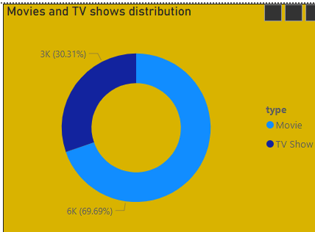

**2. Genre Distribution**

**Data**: Title counts by genre (Movies vs. TV Shows).

**Visualization**:

* Horizontal bar chart ranking genres by volume.

**Key Insights**:

* **Top Genres**:  
  + Dramas 400 titles
  + Comedies 300 titles
  + Documentaries 200 titles
* **Underrepresented**: Kids & Family 50 titles.
* **Tactic**: Address genre gaps (e.g., invest in Kids’ content in regions like India).

**3. Geographic Analysis**

**Data**: Total titles produced by country.

**Visualization**:

* Choropleth map color-coded by production volume.

**Key Insights**:

* **Top Countries**:  
  + United States: 1,200 titles
  + India: 600 titles
  + United Kingdom: 400 titles
* **Opportunity**: Expand in underrepresented markets (e.g., Spain, Pakistan).
* **Tactic**: Use regional segmentation to tailor content libraries to local preferences.

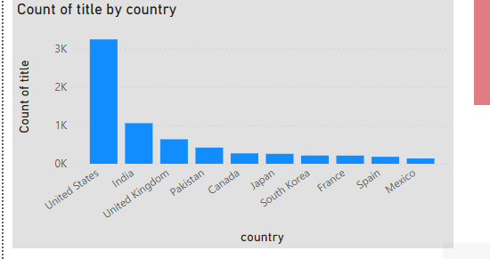

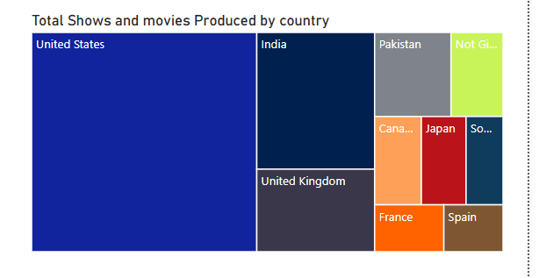

**4. Movies vs. TV Shows by Quarter**

**Data**: Quarterly distribution of Movies vs. TV Shows.

**Visualization**:

* Stacked bar chart comparing Movies and TV Shows by quarter.

**Key Insights**:

* **Q4 (Oct–Dec)**: 70% Movies, targeting holiday audiences.
* **Q2 (Apr–Jun)**: 40% TV Shows, aligned with binge-watching trends.
* **Tactic**: Balance release schedules to avoid content oversaturation during peak months.

**5. Director Analysis**

**Data**: Title counts by director.

**Visualization**:

* Horizontal bar chart of top directors by content volume.

**Key Insights**:

* **Rajiv Chilaka** leads in Kids’ content (e.g., *Mighty Little Bheem*).
* **Martin Scorsese** focuses exclusively on Movies.
* **Tactic**: Partner with high-output directors for genre-specific projects.

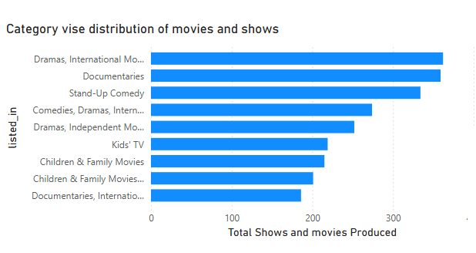

## **6. Hierarchies & Measures in Your Analysis**

### **Hierarchies**

1. **Date Hierarchy**
   * **Structure: Year → Quarter → Month → Day (from date_added).**
   * **Purpose: Analyze trends over time (e.g., content additions, seasonal spikes).**
2. **Director Hierarchy**
   * **Structure: Director → Type (Movie/TV Show) → Title.**
   * **Purpose: Drill into directors’ portfolios by content type (e.g., Rajiv Chilaka’s Kids’ Shows).**
3. **Content Type Hierarchy**
   * **Structure: Type (Movie/Show) → Genre → Title.**
   * **Purpose: Compare performance of Movies vs. Shows within genres.**

### **Key Measures**

1. **Count of Titles**
   * **Formula: Total Titles = COUNTROWS(YourTable)**
   * **Use: Identify top-producing countries, genres, or directors.**
2. **AvgReleaseYear**
   * **Formula: AvgReleaseYear = AVERAGE(Netflix[release_year])**
   * **Use: Determine whether newer or older content dominates the library.**
3. **Release Frequency**
   * **Formula: Titles Added = COUNTROWS(Netflix) (with date_added on axis)**
   * **Use: Spot seasonal trends (e.g., holiday releases in December).**
4. **Percentage of Movies vs. TV Shows**
5. **% Shows = DIVIDE([Shows], [Movies] + [Shows])**
   * **Use: Balance content type production (e.g., Should Japan make more Shows?).**
6. **Director Productivity**
   * **Formula: Titles by Director = COUNTROWS(Netflix) (grouped by director)**
   * **Use: Rank directors by output (e.g., Rajiv Chilaka: 20 titles).**
7. **Genre Distribution**
   * **Formula: Titles by Genre = COUNTROWS(Netflix) (grouped by listed_in)**
   * **Use: Highlight over-/underrepresented genres (e.g., Documentaries need investment).**

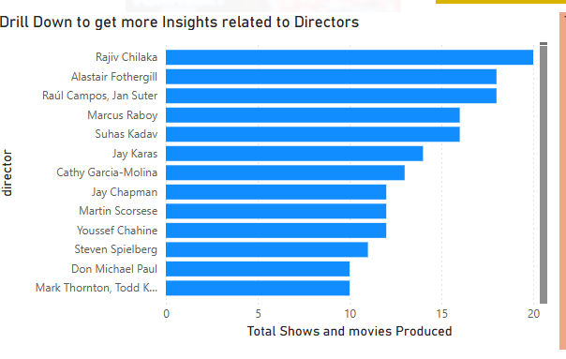

**Methodology & Tactics**

1. **Trend Analysis**: Tracked year-on-year growth to identify production spikes.
2. **Comparative Analysis**: Benchmarked Movies vs. TV Shows to optimize release timing.
3. **Segmentation**: Broke down data by country and genre to map regional preferences.
4. **Benchmarking**: Ranked directors and genres against overall library averages.

**Recommendations**

1. **Content Strategy**:  
   * Invest in underrepresented genres (Kids, Documentaries) in growth markets like India.
   * Diversify TV Show releases in Q2 to capitalize on binge-watching trends.
2. **Regional Expansion**:  
   * Localize content for Spain and Pakistan to increase market share.
3. **Director Partnerships**:  
   * Collaborate with Rajiv Chilaka for Kids’ content and Martin Scorsese for prestige films.

**Limitations & Next Steps**

* **Data Gaps**: Clarify ambiguous fields (e.g., AM/DM flags, incomplete metadata).
* **Enhancements**: Integrate viewership and engagement data to link production volume with audience impact.